|  |
| --- |
| EPAM Systems, RD Dep. |
| MTN.BI.08 Core PL/SQL |

|  |  |  |  |  |  |
| --- | --- | --- | --- | --- | --- |
| REVISION HISTORY | | | | | |
| Ver. | Description of Change | Author | Date | Approved | |
| Name | Effective Date |
| 1.0 | Initial status | Hanna Hul | 27-NOV-2017 |  |  |

Contents

1. Create Packages for Reload Dimension from SA_* 3

2. Task Results 3

# Create packages to load dimensions from source to staging (3NF) layer

The Main Task is to create independent packages to load dimensions according to your DWH solution concept that was developed on Module 6 Introduction to DWH.

Required points:

* Create all required dim objects on ST Layer (T_...).
* Grant all required privileges to ST_CL (Cleansing Layer).
* Use Explicit Cursor (One or more procedures).
* Use Implicit Cursor (One or more procedures).
* Use Merge (One or more procedures).

# Task Results

Implicit cursor

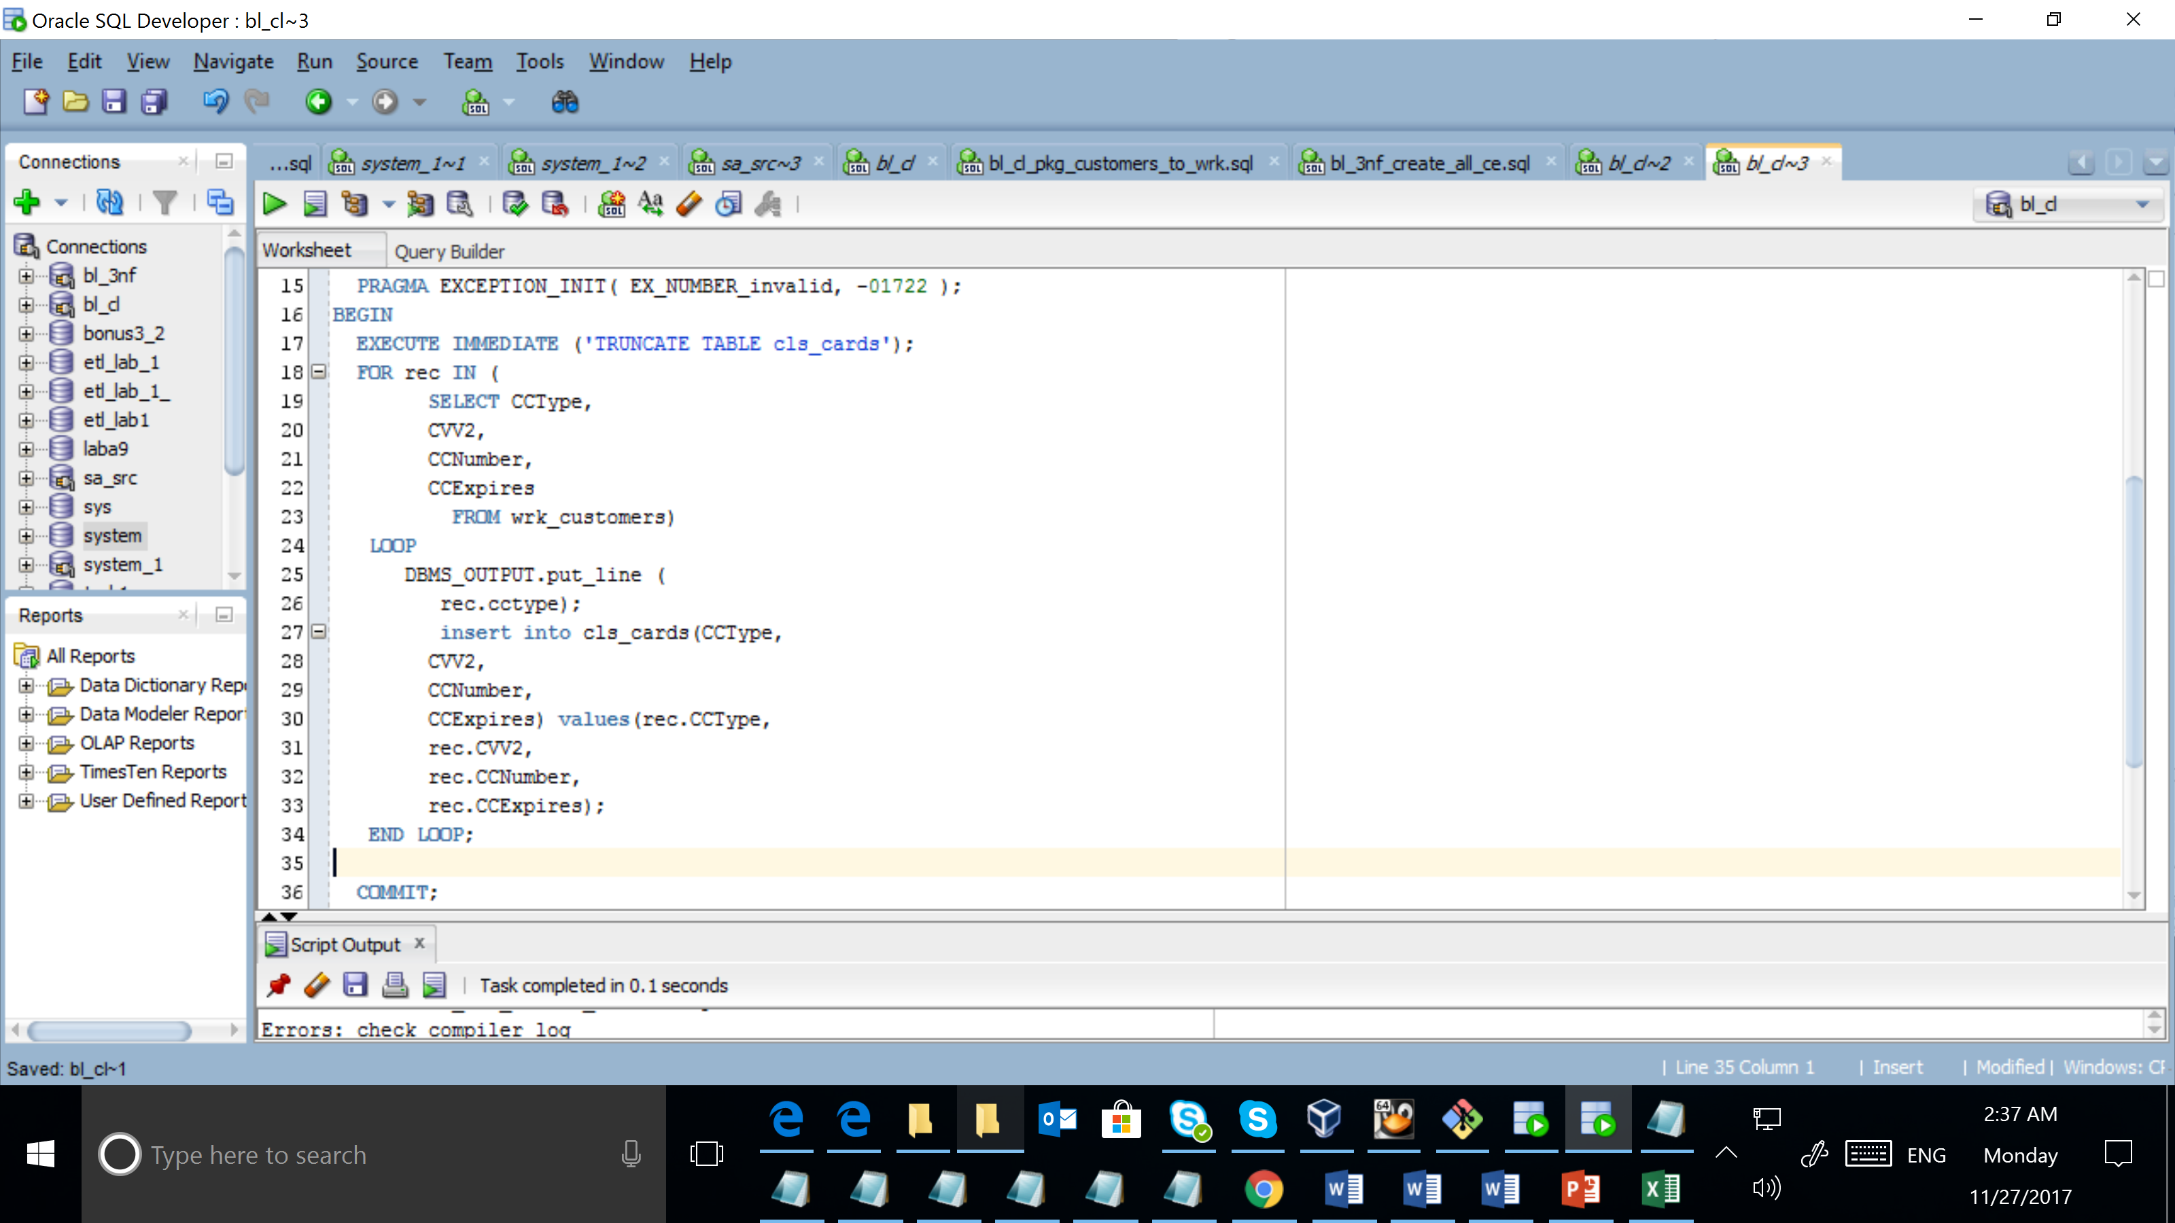

Result:

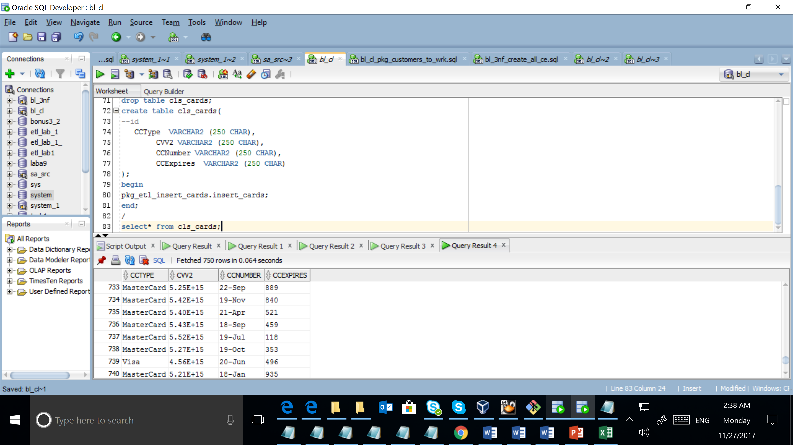

Explicit cursor

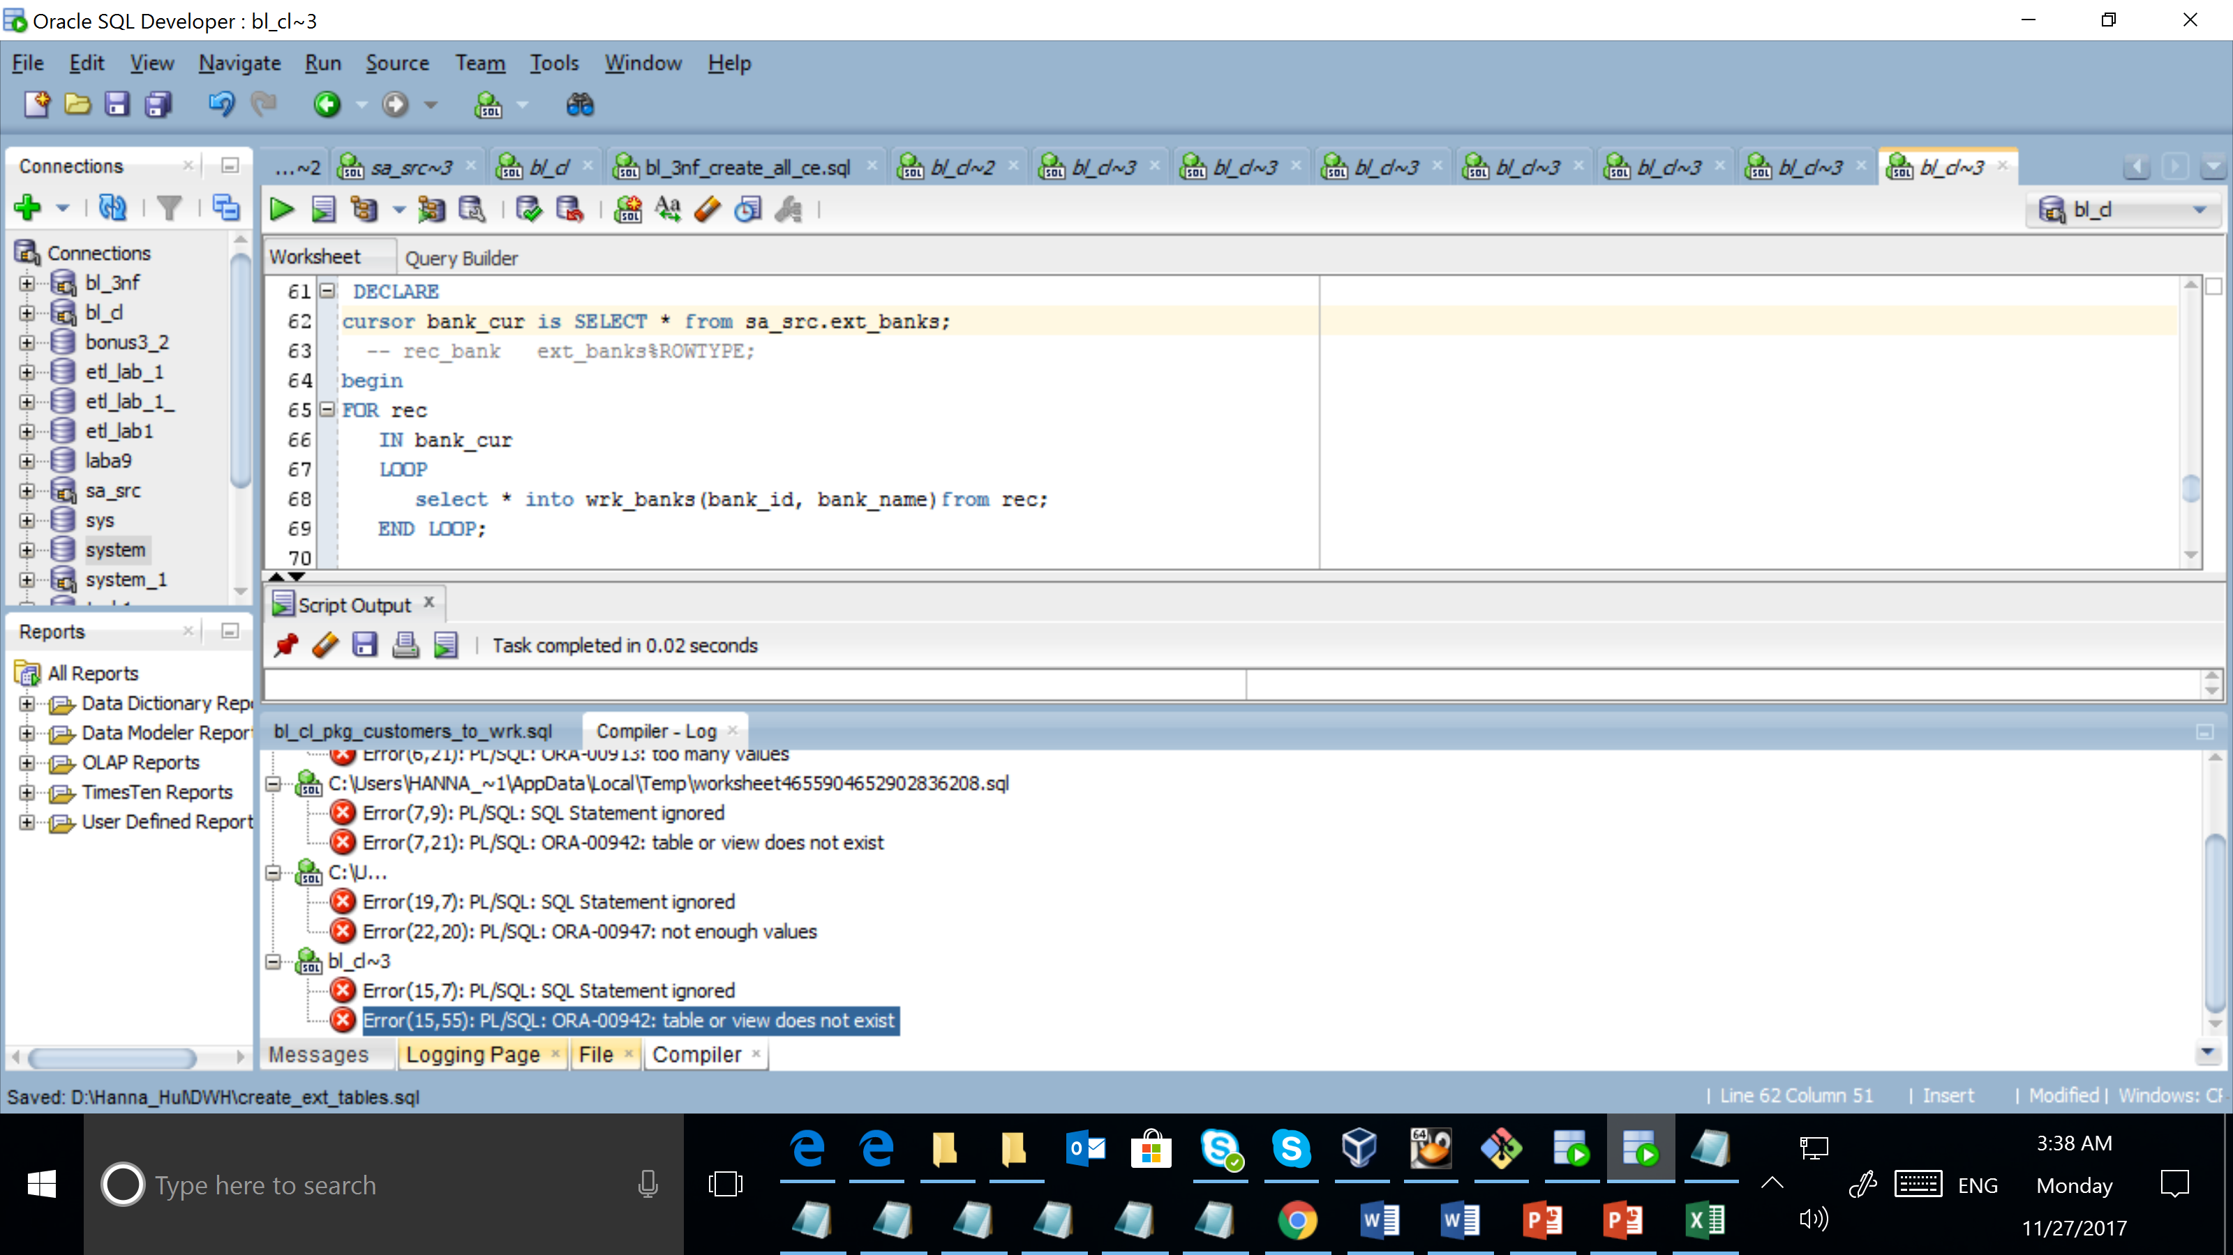

Merge

